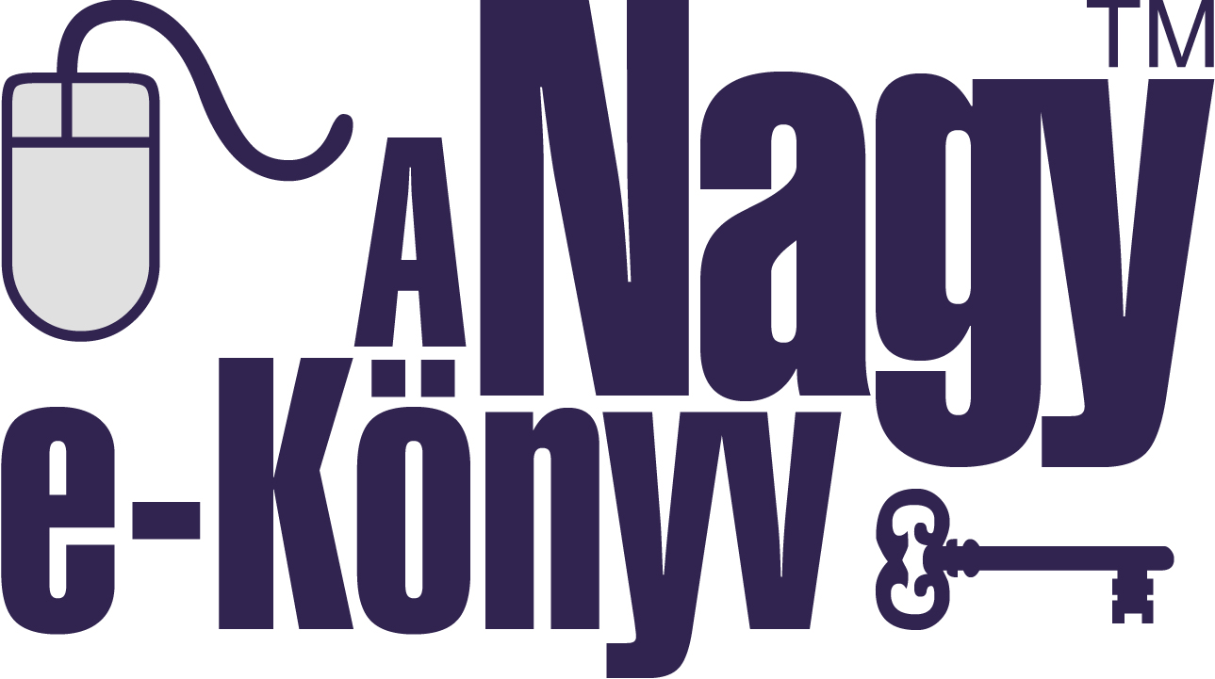
Mentor-ID: ________

C O N T R A C T
Consisting of 5 pages and its Annex, which has been concluded by and between on the one hand
(seat, tax No., company registration No., registered e-mail address: ,
represented by: ) (hereinafter referred to as: the Publisher), and on the other hand A Nagy e-Könyv Programiroda Kft. (The Big eBook Program Office Ltd.) (tax No.: 22694706-1-06, company registration No.: 06-09-015491, seat: 6754 Újszentiván, Boján u. 8., represented by: Csaba Tápai, managing director), (hereinafter referred to as: the Program Office), (the Publisher and the Program Office hereinafter collectively referred to as: the Parties) at the place and on the date indicated below, under the following conditions:

- Definition

  - For the purposes of this Contract an electronic book (abbreviated to: ebook) is defined as: A text in digital format, written in any language, which can be supplemented with multimedia elements; an electronic reading material adapting the functionality of traditional paper books in part or in full, or even exceeding it, or a device for carrying-playing-communicating such information.

- Subject of the Contract

  - The Program Office is granted the right to prepare the ebook versions of (paper-based or other) traditional book publications, as well as author manuscripts and other source works under the editorship of the Publisher – hereinafter referred to as: works – and to commercially distribute such ebooks.

  - Under this Contract the Publisher grants a right of use to the Program Office for the works listed in the Annex – forming an integral part of this Contract.

- Obligations of the Program Office

  - The Program Office shall be obliged to create a demonstration and a commercial ebook version for each work delivered under section 4.2 and to organize them into its database. If the inclusion of a given work into the database is not performed by the deadline through the fault of the Program Office, then it shall be obliged to refund to the Publisher the registration fee payable for the work according to section 4.5, if it has been paid by the Publisher in advance.

  - The Parties shall not make accessible to unauthorized persons any digital sources, ebooks not yet subjected to a copyright and copy protection procedure, they shall be obliged to protect them from unauthorized access. The Program Office shall be obliged to include the “A Nagy e-Könyv” (The Big eBook) trademark registered by the Hungarian Patent Office and its web address (www.thebigebook.eu) in both the external appearance and the internal content of the electronic adaptation, together with the imprint of the Publisher and its own imprint.

  - The Program Office shall not demand any other fee for the creation of the demonstration and full version ebooks in addition to the registration fee payable according to section 4.5 from either the Publisher or the authors of the works listed in the Annex. If, however, in addition to the basic full version (text, photos, figures) an extended version is also prepared (e.g. machine or human voice narration, additional video, audio recording, etc., that is not standard book-like services), the Parties shall agree on a fee for the preparation thereof by the Program Office in a separate contract.

  - The Program Office shall not be held responsible for any agreement concluded between the Publisher and the authors of the works listed in the Annex.

- Obligations of the Publisher

  - The Publisher shall be obliged to include the imprint of the Program Office in the reprinted or newly published non-ebook copies of a work, if the given work has been created by the Program Office as an ebook and organized into its database in accordance with this Contract.

  - Works available in an electronic form shall be made available to the Program Office by the Publisher electronically within 8 working days from this day in one of the following formats: Adobe-PDF (PDF), Microsoft Word (DOC).

  - Works not available in an electronic form (paper-based printed works - typically books) shall be made available to the Program Office by the Publisher in 1 copy each within 8 working days for the purpose of conversion into an ebook. Conversion will be made into the Adobe-PDF format as well, which the Program Office shall be obliged to deliver to the Publisher. The Publisher shall pay a separate fee to the Program Office for the conversion into the PDF format, the amount of which shall be set forth in a separate agreement.

  - The Publisher undertakes the obligation to provide to the Program Office the available product information with respect to the works (publisher details, author details, publication details such as title, subtitle, series title, ISBN, ISSN, cover designs, full-featured source files of satisfactory quality, font sets if necessary, maximum 10 search keywords per work, classification according to the category system of the Program Office, year of first and last publication) in the course of the performance of this Contract, and undertakes to cooperate with the Program Office according to its competence in meeting customer needs related to electronic adaptation and the distribution of ebooks.

  - The Publisher shall be obliged to pay a registration fee for the works listed in the Annex. The registration fee shall be determined by means of the current fee calculator available on the website of the Program Office (www.thebigebook.eu/regdij.html). The fees payable shall be set forth in the Annex. The fees may be paid in advance or in arrears (POST payment). In the latter case the fees payable by work are paid from the total sales of the works listed in the Annex. If this Contract terminates, any part of the fees calculated for such works and still outstanding shall become payable in one sum and immediately. The amount of the fees payable in advance for the works listed in the Annex is EUR say Euros, which the Publisher shall be obliged to pay in one sum by bank transfer to bank account No. 11735005-20574121 (OTP Bank Zrt., Hungary) of the Program Office within 8 days from this day. The following shall be indicated in the comment line: “Registration fee”. The fees set forth in this Contract and its Annex shall not be affected by any subsequent changes to the fee calculator. The fees set forth in this section shall not be affected by any subsequent modifications of the works.

  - The Publisher and the authors of the works listed in the Annex, in accordance with the contracts concluded between them, shall assume responsibility for the contents of the works, the responsibility of the Program Office in this respect is fully excluded, which is expressly accepted by the Publisher. The Publisher shall be responsible towards the Program Office for the performance of the contracts concluded with the authors of the works in any other aspects affecting the Program Office as well.

- Scope of use, remuneration

  - The Publisher grants the following rights of use to the Program Office exclusively, without territorial limitation worldwide, for the whole duration of the protection of the works, or at least for the term of the contracts concluded between the authors and the Publisher with respect to the works listed in the Annex (any time limit for the use shall be indicated in the Annex by work!):

- communication to the public, including in particular the case of:

providing online accessibility:
When the work is made available to the public by cable or any other means or in any other manner in a way that the member of the public can choose the place and time of access individually.

- distribution (offline distribution of digital copies of the works, e.g. on CD-ROM)

- the conversion of the works into ebook format

- the reproduction of the works in electronic form (digitally)

  - In the case of the right of use “the reproduction of the works in electronic form (digitally)” the Publisher allows the Program Office to transfer the right of such use to a third party.

  - Should the uses specified in this Contract change/expand during the term of the Contract in a way allowing the more efficient implementation, under more favourable conditions or in higher quality, of the uses known at the time of the conclusion of the Contract and granted in the Contract, the rights of use granted under this Contract shall cover such changed or expanded uses. The Program Office shall be obliged to inform the Publisher of any such change or expansion.

  - The Program Office shall pay to the Publisher a license fee equal to 50% of the revenues from the distribution of the ebook versions of the works listed in the Annex to this Contract, more precisely the amounts actually received as consideration for the sold end-use licenses, which will cover the royalties as well. The value of the latter shall be as set forth in a separate agreement between the Publisher and the Author. No license fee shall be payable to the Publisher until any registration fee is outstanding even for one work.

  - Revenues from the sales of media and the hardware devices ensuring copyright protection, disc writing, device formatting, and other additional services (such as the sales of advertising spaces) shall not be taken into account by the Program Office in the calculation of the amounts payable to the Publisher and the authors, those items are the own revenues of the Program Office outside the scope this Contract, which are expressly accepted as such by the Publisher. The Program Office shall not be entitled to include advertisements in the ebook files without the permission of the Publisher.

  - The Publisher represents and warrants that it has the granted rights of use and the right to transfer them to the Program Office with respect to the work(s) listed in the Annex.

  - The Publisher warrants that there are no copyright and other legal barriers to the use of the works in ebook versions under the conditions specified in this Contract, and that they are free from encumbrances. The Publisher shall be obliged to reimburse 100% of any proven damage resulting from the supply of false information – suffered by the Program Office.

  - The Program Office shall have no legal or financial responsibility whatsoever with respect to the validity of the rights of use granted in this Contract, such responsibility is expressly excluded by the Program Office, any claims arising therefrom shall be made exclusively to the Publisher.

  - The Program Office shall have no legal or financial responsibility whatsoever for the unauthorized use of the works by any third party (e.g. by illegally scanning, photocopying the original source paper book, capturing screenshots, text transcription, etc.), such responsibility is expressly excluded by the Program Office, the Publisher shall not be entitled to make any claims arising therefrom against the Program Office.

  - The Publisher undertakes with respect to the works listed in the Annex not to conclude a contract with any third party for the production, distribution of ebooks, not to engage in any ebook adaptation beyond the business interests of the Program Office, or not to distribute, promote ebook versions on its own or other websites - or elsewhere -, however the free demonstration (demo) version ebooks created by the Program Office may be stored in a publicly accessible manner, promoted on its own website (if it has one). The Publisher warrants that the obligations undertaken in this section will be performed jointly with the authors.

- Settlement of accounts

  - The Program Office shall be obliged to meet its payment obligations arising from the end-user license fees received from the sales of the commercial ebook versions in accordance with sections 5.4. and 5.5. on a monthly total basis by the 15th day of the month following the relevant month, and to send an itemized monthly statement of the actual sales to the Publisher. The statements shall be sent to the e-mail address of the Publisher given in this Contract, the Program Office shall be notified of any change in the address without delay.

  - For the first 10 end-user license fees by commercial license, the Program Office shall transfer the amount payable only by the 15th day of the month following the relevant month in which the 10th end-user license fee has been received on the account of the Program Office, but the transfer delayed in this way shall be made by the 15th day of the 13th month following inclusion into the database the latest. For the purposes of this section there is no difference between group use as specified in any separate agreement and individual use according to this Contract, that is in this respect group use shall be regarded as individual use. The delay cycle shall restart in every month in which a transfer is made.

- Termination

  - The Publisher declares that it waives its right of termination for a period of 5 years from the signing of this Contract.

- Breach of Contract

  - The Publisher undertakes the obligation to pay compensation to the Program Office with respect to proven loss of business profits, if it fails to meet its obligations specified in this Contract, in particular if

- it does not have a valid license – covering any uses specified in this Contract – for a given work,
- any third party has rights to a work delivered for use conflicting with the interests of the Program Office,
- the lawful use of a delivered work fails, becomes impossible through other acts of the Publisher.

- Term of the Contract

  - The Parties conclude this Contract for a definite term starting on this day and expiring on:

  - Within 6 months from the date of expiry this Contract may be extended by the mutual agreement of the Parties.

  - If either of the Parties demand it, this Contract may be reviewed annually, and amended as appropriate, provided that the amendment will not put either of the Parties in a less favourable position.

- Miscellaneous provisions

  - This Contract and its Annex have been drawn up in 2 identical copies each. The Program Office shall return to the Publisher one copy of both document types, signed by it, within 8 days from the receipt of the documents the latest.

  - The Parties shall treat the details of this Contract as business secret and shall not disclose them to any third party, however the fact and substance of their contractual relationship may be freely promoted to the public.

  - The Parties shall attempt to settle any disputes arising between them primarily by way of negotiations. Should they fail to settle any dispute by way of negotiations, they stipulate the exclusive jurisdiction of the Szeged City Court for the settlement of all legal disputes between them.

  - Issues not regulated in this Contract shall be governed by the provisions of the act on copyright and the Civil Code.

The Parties have read and understood this Contract and its Annex, and signed them in approval as being in full compliance with their intentions.
Date: ,
Place of Seal Place of Seal

for the Publisher for “A Nagy e-Könyv Programiroda Kft.”
(The Big eBook Program Office)
Csaba Tápai, managing director

